**Title**: Title of the Abstract (Arial font – 12 point size)

**Author(s)**: Sophia Newton*1, John Smith2, etc. (Arial font – 11 point size, mark the speaker with *)

*1 Department, Affiliation, City, Country, Email address (Arial font – 10 point size, italic)*

*2 Department, Affiliation, City, Country, Email address (Arial font – 10 point size, italic)*

**Keyword(s)**: keywords list (Arial font – 11 point size)

**Abstract**

Abstracts must not exceed 4 (A4) pages, including table, figures and references..

The abstract text should be written in Arial font with 11 point size.

Type or paste your text into this abstract template, but remember to keep the page margins the same as is set here which is 2 cm all round. Paragraphs are justified (straight-edged) on both left and right. The abstract must be written in English.

The papers in the reference list must be cited in the text. In the text, the citation should appear in square brackets “[1]”. In the Reference list, the font should be Arial with 10 point size. The citation number should be enclosed in brackets.

The final pdf of the abstract must be submitted through the official website, following the instructions given there, by the abstract submission deadline. When submitting, make sure to choose the correct mini-symposium for your submission and fill all the fields required in the upload form.

The file name should have the following pattern: FirstAuthorLastname.pdf.

**Table 1.** Table title (centered)

| **Title column** | **Title column** | **Title column** |
| --- | --- | --- |
| Text | Text | Text |
| Text | Text |  |
|  |  |  |

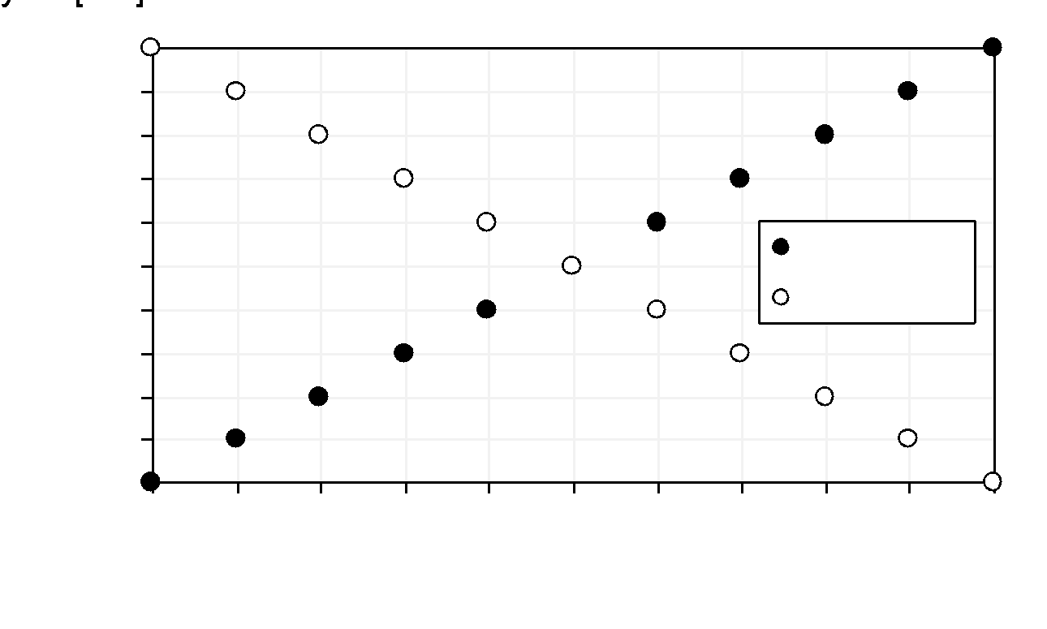

**Figure 1.** Table title (centered)

**References**

[1] Becker S., Thompson A., “The title of the paper” in Proceedings of Conference Title, where it took place, date of conference, page ??, (year of publication).

[2] Jones P.A., Book Title, Publisher, City (year of publication).

[3] Stones R., Green J.M., “The title of the paper,” Journal Name, Vol, page ??, (year of publication).